STRING

Using Length gets ,scanf,getchar(()

 Using String handling functions

Length of string

 Comparing two strings

 Copying two strings

 Concatenating two strings

 reversing the strings

1. STRING HANDLING FUNCTIONS

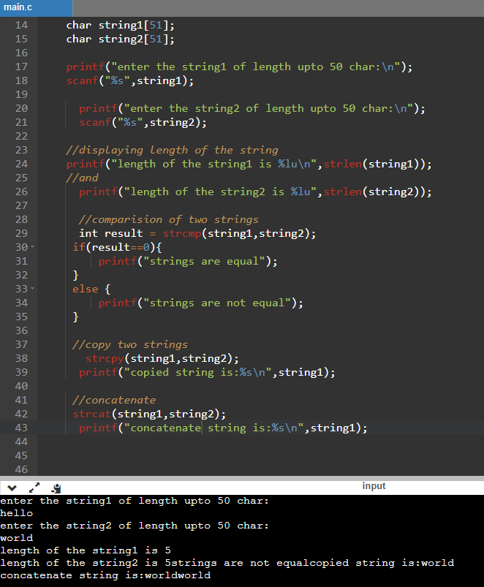

1. CONCATENATING TWO STRINGS

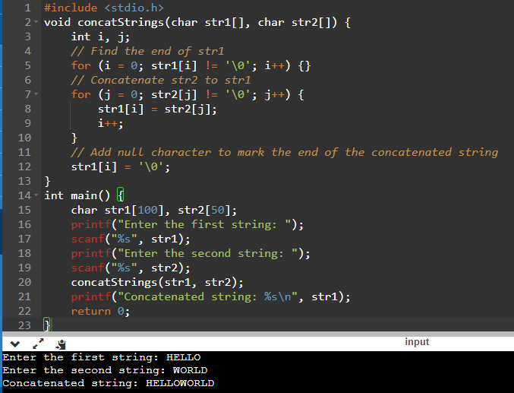

Dry run: considering string1 be “hello” and string2 be “world’

|  |  |  |  |  |  |
| --- | --- | --- | --- | --- | --- |
| i | Str[i] |  | j | Str[i]=Str[j] then |  |
| 0 | H Str[0] |  | 0 | W Str[0] |  |
| 1 | E Str[1] |  | 1 | O Str[1] |  |
| 2 | L Str[2] |  | 2 | R Str[2] |  |
| 3 | L Str[3] |  | 3 | L Str[3] |  |
| 4 | O Str[4] |  | 4 | D Str[4] |  |
| 5 | ‘\o’ Str[5] | exit | 5 | ‘\0’ Str[5] | exit |

1. REVERSE A STRING

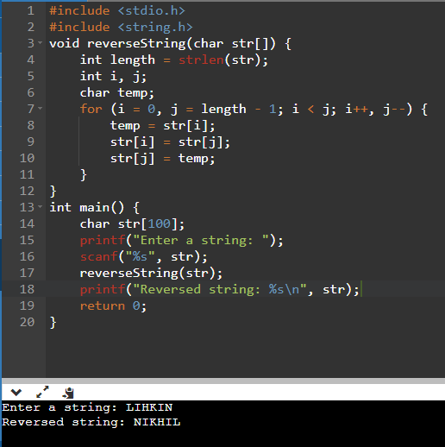

Dry run

Considering string to be “hello” length to be 5

|  |  |  |  |  |  |
| --- | --- | --- | --- | --- | --- |
| i | j | i<j | temp | Str[i] | j |
| 0 | 3 | Yes | H | L | H |
| 1 | 2 | Yes | E | L | E |
| 2 | 1 | no |  |  |  |
| 3 | 0 | no |  |  |  |

1. LENGTH OF STRING

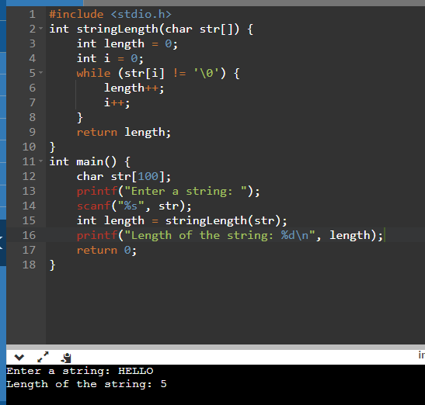

Dry run

Considering the string “hello”

|  |  |  |
| --- | --- | --- |
| i | len | Str[i] |
| 0 | 0 | H |
| 1 | 1 | E |
| 2 | 2 | L |
| 3 | 3 | L |
| 4 | 4 | O |
| 5 | 5 | ‘\o’ -stop |

1. COMPARING TWO STRINGS

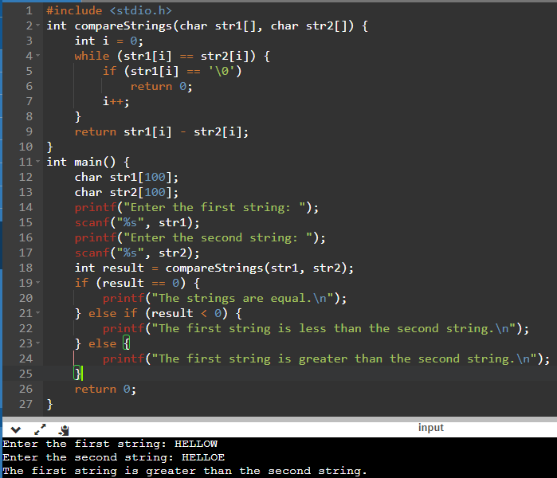

Dry run

comparing string1”hello” and string2 “world”

|  |  |  |
| --- | --- | --- |
| Str1 | Str2 | compar |
| Str[0] | Str[0] | If = |
| Str[1] | Str[1] | = |
| Str[2] | Str[2] | = |
| Str[3] | Str[3] | = |
| Str[4] | Str[4] | =  Then value will be o means same string |
|  |  | If even one is unequal then string not same |

|  |  |  |
| --- | --- | --- |
| Str1 | Str2 | Com |
| h | w | <>  String not equal |
|  |  |  |
|  |  |  |
|  |  |  |

1. COPYING ONE STRING INTO ANOTHER

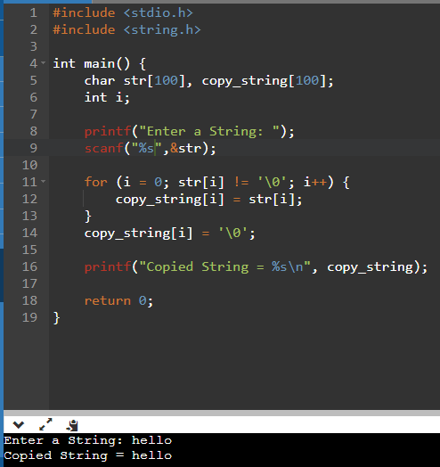

Dry run

Considering str1 “hello”

|  |  |  |
| --- | --- | --- |
| i | Str1 | Copy_str |
| O | H | H |
| 1 | E | E |
| 2 | L | L |
| 3 | L | L |
| 4 | O | O |
| 5 | ‘\0’ |  |

Length –gets ,scanf, agetchar(()

